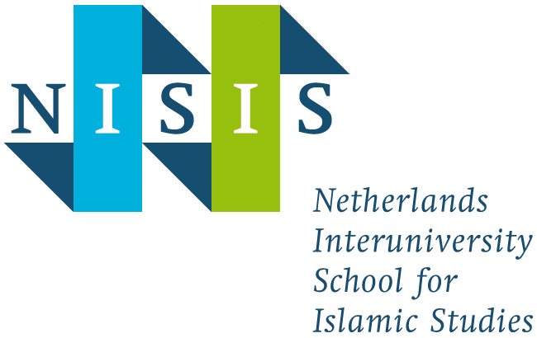

Course description: NISIS/ACMES Workshop “Islamic and Middle Eastern Studies in Dialogue”

Theme | This workshop aims to facilitate a dialogue between Islamic Studies and Middle Eastern Studies.
Academic year | 2018-2019
Semester | 2
EC | 1
Level | 600
Language | English
Speakers | Dr. Farid Boussaid  Prof. Thijl Sunier  Dr. Maaike Voorhoeve  Prof. Gerard Wiegers
Hosted by | University of Amsterdam

Admission requirements

PhD candidates and research master students who study Muslims, Muslim societies and Islam in the broadest sense of the word may apply for admission and should contact NISIS at nisis@uu.nl.

NISIS junior members qualify automatically and do not need to apply for participation. However, they are required to register for the Workshop via www.nisis.nl.

Description

Islamic and Middle Eastern studies are cognate academic disciplines, but scholars in both fields often go about their research in relative isolation from each other. Various reasons account for this, not least institutional ones: Middle Eastern Studies and Islamic Studies tend to be associated with separate university units (and hence with different research epistemologies), the former with area studies, the latter with religious studies and theology. Middle Eastern Studies often emphasize the political, social and economic organisation of the modern and contemporary Middle East, while Islamic Studies include areas of the Islamic world beyond the Middle East and devote substantial attention to the formative and middle periods of Islamic civilisation. Most controversially, perhaps, the two disciplines tend towards divergent evaluations of the role played by Islam in the history and current configuration of the Middle East. Yet in spite of these dissimilarities, researchers in both areas, in many fruitful ways, benefit from each others’ work. This workshop seeks to facilitate conversations between researchers from both disciplines, by inviting Dr. Maaike Voorhoeve (University of Amsterdam), Dr. Farid Boussaid (University of Amsterdam), Prof. Thijl Sunier (VU Amsterdam) and Prof. Gerard Wiegers (University of Amsterdam) to reflect on common themes, and engaging the broader community of Middle Eastern and Islamic Studies scholars in a conversation about their mutual perceptions and shared research interests.

Participants (PhD candidates and research master students) are required to:
- read the set literature (four articles/book chapters) in advance
- participate in the discussions during the workshop
- write a short reflection of max. 500 words on the workshop and at least two of the articles provided by the speakers.

Course objectives

- Enlarging and deepening knowledge of Muslim societies and the Middle East
- Providing insight and participation in current methodological debates in Islamic Studies and Middle Eastern Studies
- Introducing participants to the national network of scholars in both fields
- Enhancing dialogue and collaboration between junior and senior researchers in Islamic Studies and Middle Eastern Studies
- Training writing and reflection skills

Timetable

Workshop Friday May 24, 2019.
Programme:
13.30-13.40: Welcome by NISIS director Prof. Christian Lange
13.40-15.00: Session 1: Authority
Thijl Sunier (VU Amsterdam) and Farid Boussaid (UvA)
15.00-15.30: Coffee and tea
15.30-17.00: Power
Maaike Voorhoeve (UvA) and Gerard Wiegers (UvA)
17.00: Drinks
Deadline reflection report: Friday May 31, 2019
Please make sure to check the NISIS website about program details and updates: www.nisis.nl

Mode of instruction

- Workshop
- Writing reflection report (max. 500 words)

Course load

Total course load is 16 hours
Preparation meeting (reading literature): 8 hours
Attendance meeting: 4 hours
Preparation reflection: 4 hours

Assessment method

The examination of PhD candidates and research master students is based on:
- attendance of the meeting;
- written reflection

Requirements reflection report

The objective of the report of the course ‘Islamic and Middle Eastern Studies in Dialogue’ is:
- to reflect on the discussions during the workshop
- to relate the issues raised to at least two of the four articles provided by NISIS
- to train writing skills.

Reading list

Van Koningsveld, P.S. and Gerard Wiegers. “The Islamic Statute of the Mudejars in the Light of a New Source” Al-Qantara 17, no. 1 (1996): 19-58.

Maghraoui, Abdelsalam. “Political Authority in Crisis: Mohammed VI's Morocco” Middle East Report, no. 218 (2001): 12-17.

Sunier, Thijl. “Moral Failure, Everyday Religion and Islamic Authorization.” In: Straying from the Straight Path: How Senses of Failure Invigorate Lived Religion, edited by Daan Beekers and David Kloos, 107-124. New York: Bergbahn, 2017.

One more article t.b.a.

Application

You can apply for participation in the NISIS course as soon as a call for application has been opened. This will be announced on the NISIS website (www.nisis.nl). Please note that the number of available places is restricted.

NISIS junior members qualify automatically and do not need to apply for participation. However, they are required to register for the NISIS course via www.nisis.nl.

