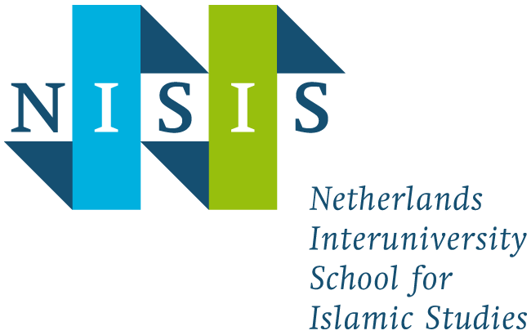
NISIS Membership
Application form for
research master students

This form is a request to be admitted as a junior member of the Netherlands Interuniversity School for Islamic Studies.
Please send this form by email to nisis@uu.nl.
The application will be evaluated by the NISIS board. The selection will be made on the basis of relevance of the research to the aims of NISIS. Research master students will be informed by the NISIS bureau as soon as the board has taken a decision.
Note: the following data will be used in documents and statistics of NISIS. Therefore, the information must be complete and accurate. Your email address will be sent to the representatives of the NISIS Junior Research Council, so they can contact you about matters related to the Junior Research Council. Every NISIS junior member is automatically a member of the Junior Research Council. For more information about the Junior Research Council, please click here.
If you do not want to receive emails from NISIS, please check the box.
At any time you can contact nisis@uu.nl for questions about or changes in your personal data, or if you would no longer be part of the mailing list.
Please do not fill in this form by hand, but use the computer!

Personal data
Name
Email address
Student number

Bachelor’s degree
Study programme
University
Examination date

Current affiliation
Study programme
University
Faculty
Department
Start of study (month + year)

Bachelor thesis
Title
Short description
Supervisor(s)

Master thesis project (as far as already known)
Title
Short description
Supervisor(s)

